**AuthService**

[Deployment Instructions_V1.0]

|  |  |  |  |
| --- | --- | --- | --- |
| **版本** | **作者** | **时间** | **修订描述** |
| V1.0 |  | 2022.06.08 | AuthService Deployment Instructions |
|  |  |  |  |

Index

1. Tomcat Installation 2

2. War build and deployment 3

## 1. Tomcat Installation

**Environment Requirements**

Operating System：Windows 10

JDK version：JDK8+

Database：no required

|  |  |  |
| --- | --- | --- |
| **INDEX** | **FILE** | **Note** |
| scipts | None | none |
| install_files | AuthService:war | The service war package |

**Deployment**

1. Download Tomcat package from website, you can download version v8.5.40 from here: <http://archive.apache.org/dist/tomcat/tomcat-8/v8.5.40/bin/>

Then config Tomcat location in Intellij:

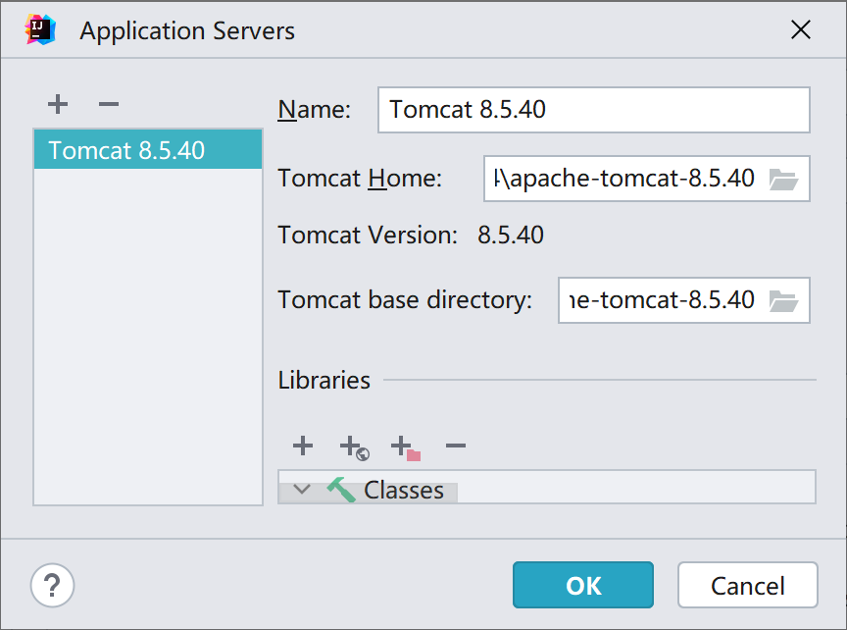

## 2. War build and deployment

B. build war package of the program by the following command:

$ mvn package

After that, you will get the war of the project, which is ready to be deployed into the Tomcat.

C. config war exploded in Intellij

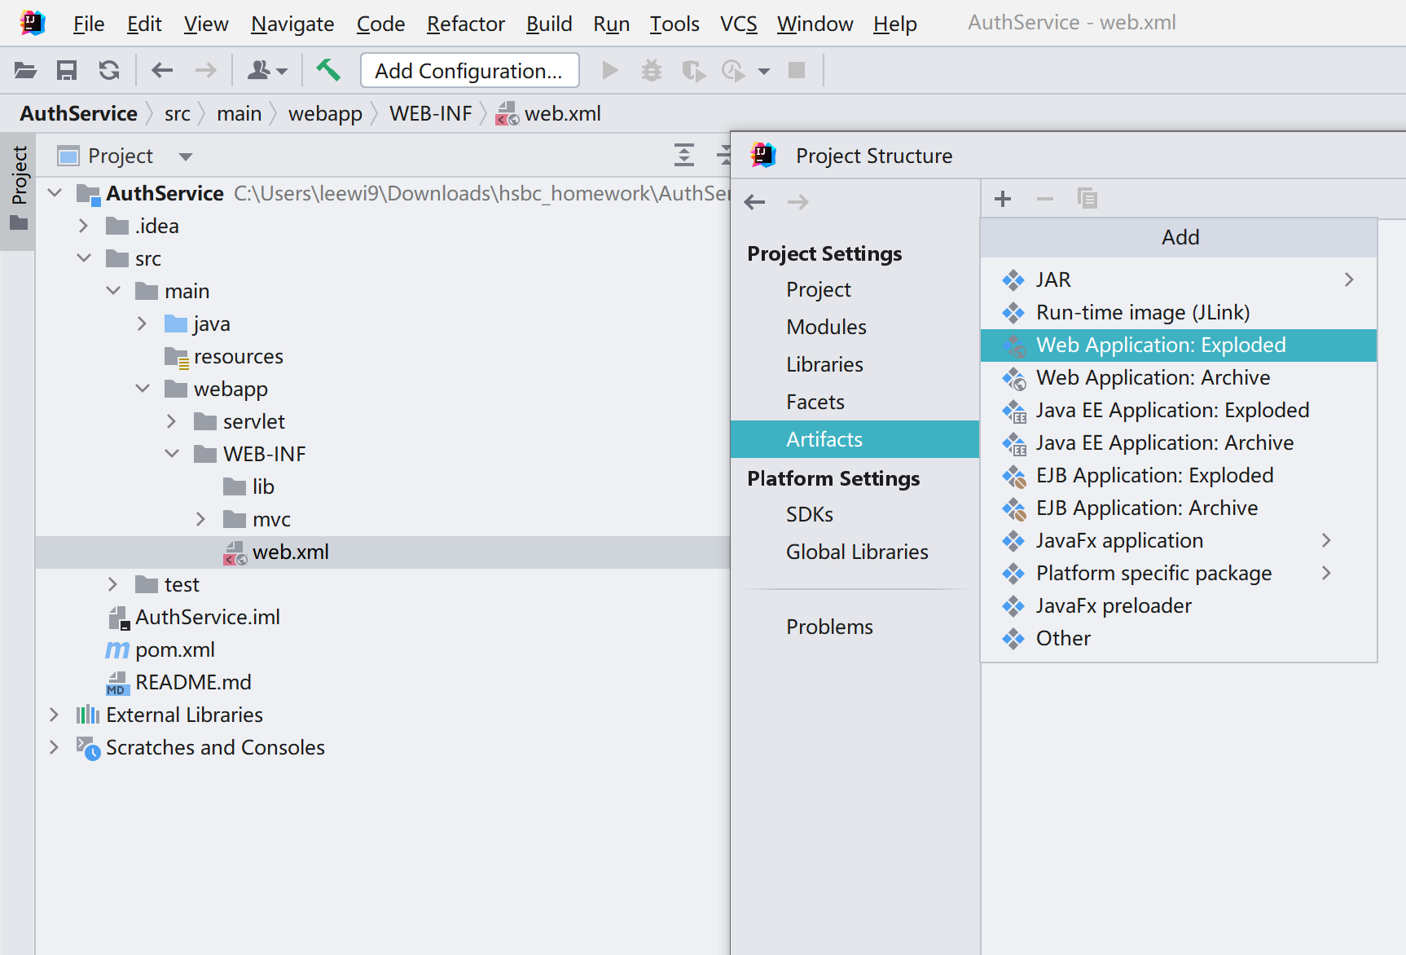

D. Select Artifact, then select AuthService:war exploded, then click Apply.

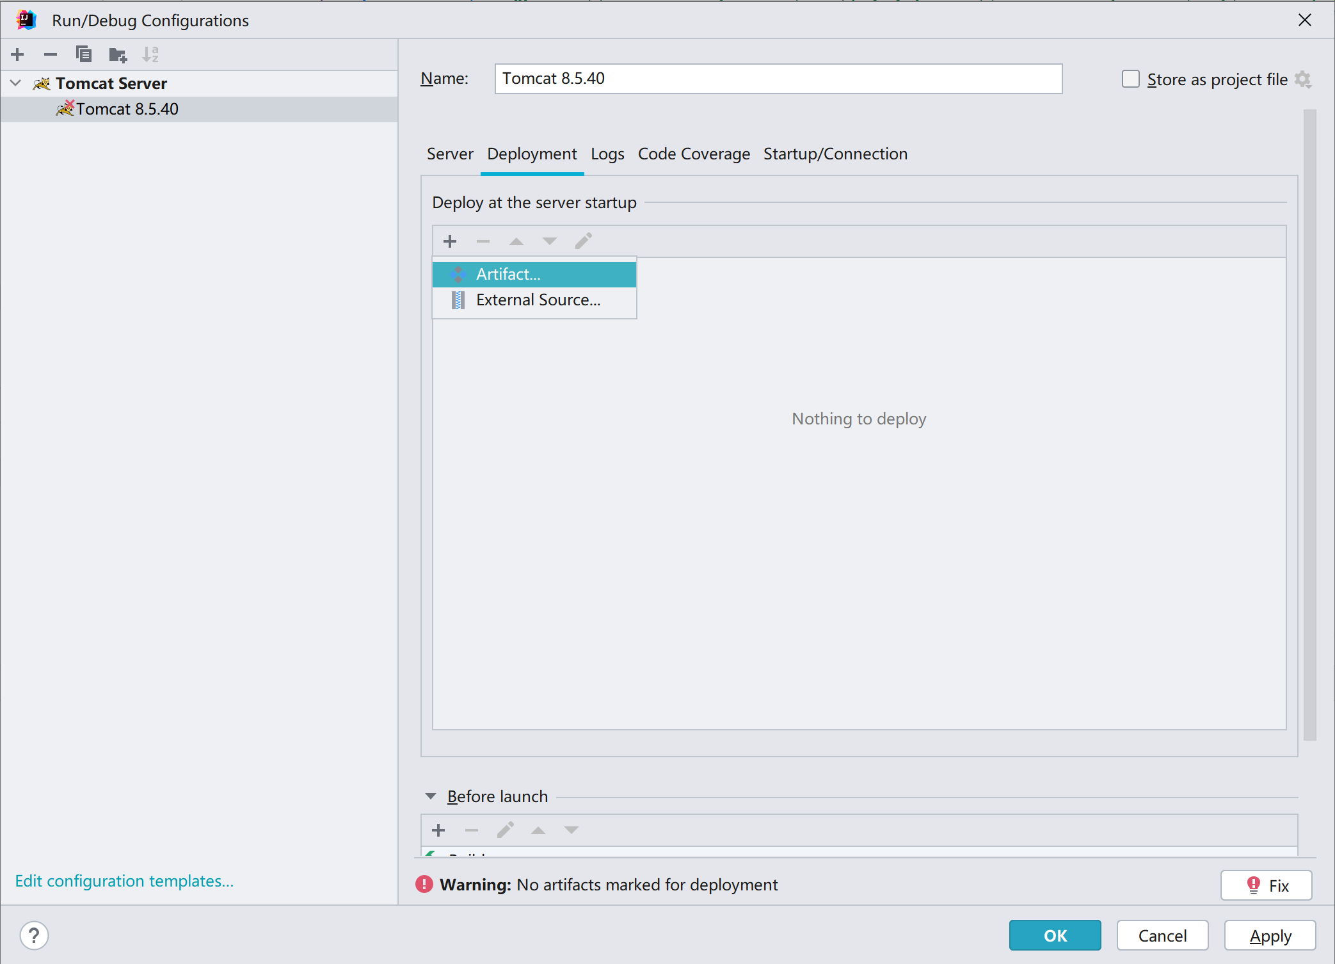

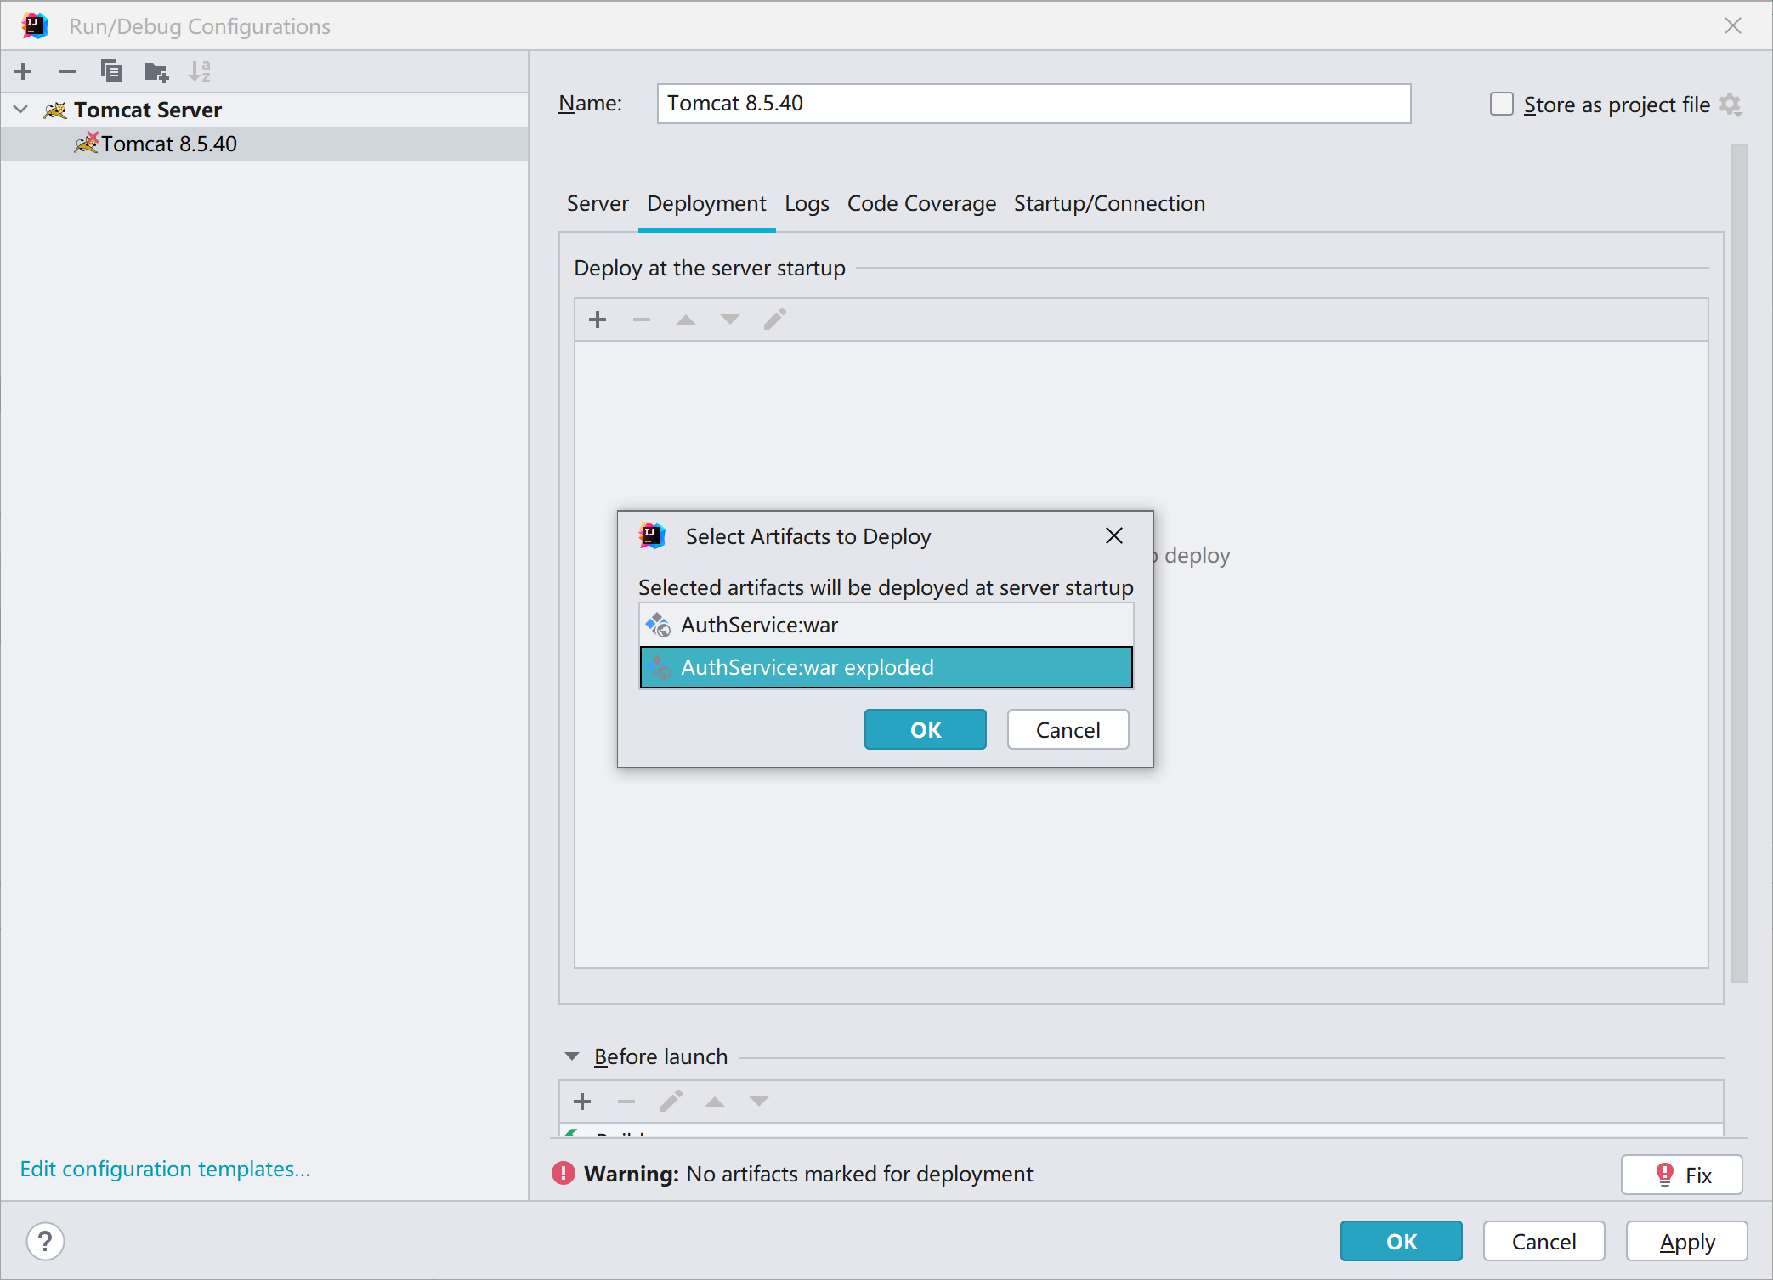

E. After deployment, call service by API endpoints. The endpoint and server port should be preconfigured by the host.

For example, you can use localhost and port 8080, then create user by call api url:

<http://localhost:8080/UserCreate.jsp>